EXPERIMENT 2
DATE :
Determination and plotting of Electric field and Electric flux density in sphere full of charges with varying radius.
Aim:
To write program for electric field and electric flux density in sphere using MATLAB.

Software required:
MATLAB (R2018 or later)
Program:
Test case (i) Determination and plotting of electric field and electric flux density in sphere full of charges with varying radius
clc;
clear;
q=input('Enter the value of q=');
r=input('Enter the value of r=');
epsilon=8.854e-12;
k=1/(4*pi*epsilon);
E=k*q/(r^2);
disp("The electric field is");
disp(E);
D=epsilon*E;
disp("The flux density is");
disp(D);
% Plot
x=linspace(0.1,10,50);
E_plot=k*q./(x.^2);
D_plot=epsilon*E_plot;
figure;
subplot(1,2,1);
plot(x,E_plot);
xlabel('Radius');
ylabel('Electric field');
subplot(1,2,2);
plot(x,D_plot);
xlabel('Radius');
ylabel('Flux density')
Output:-
Enter the value of q=2*10^-2
Enter the value of r=0.1*10^-3
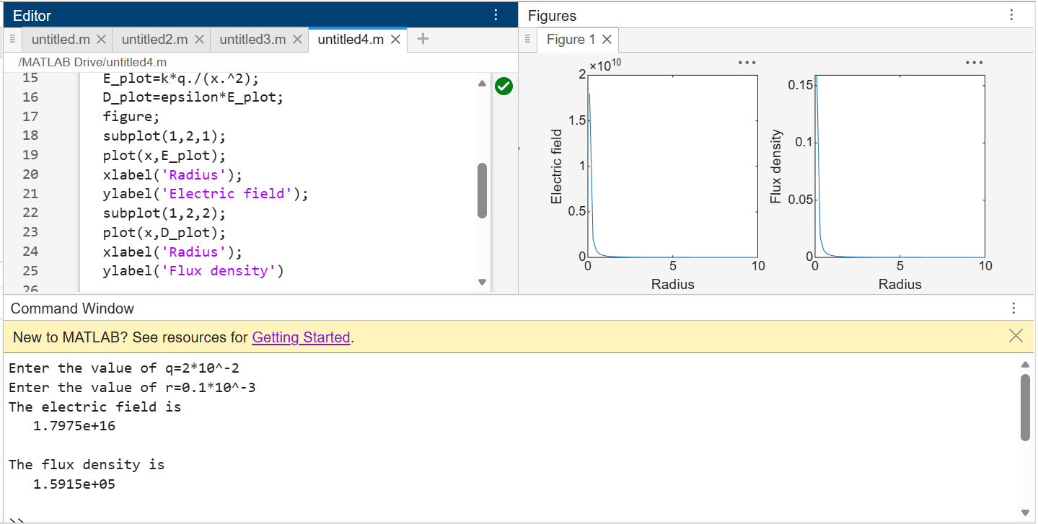
Test case (ii) Derive and plot the electric field (E) and electric flux density (D) inside a uniformly charged sphere with charge density ρ₀
Program:
clc;
rho0 = 1e-6;
epsilon = 8.854e-12;
R = 1;
r = linspace(0, R, 100);
D = (rho0 .* r) / 3;
E = D / epsilon;
subplot(1,2,1);
plot(r,D,'LineWidth',2);
xlabel("Radius (m)");
ylabel("Electric Flux Density (D)");
title("Uniform Density: D vs Radius");
subplot(1,2,2);
plot(r,E,'LineWidth',2);
xlabel("Radius (m)");
ylabel("Electric Field (E)");
title("Uniform Density: E vs Radius");
Output: Linear increase in D and Linear increase in E
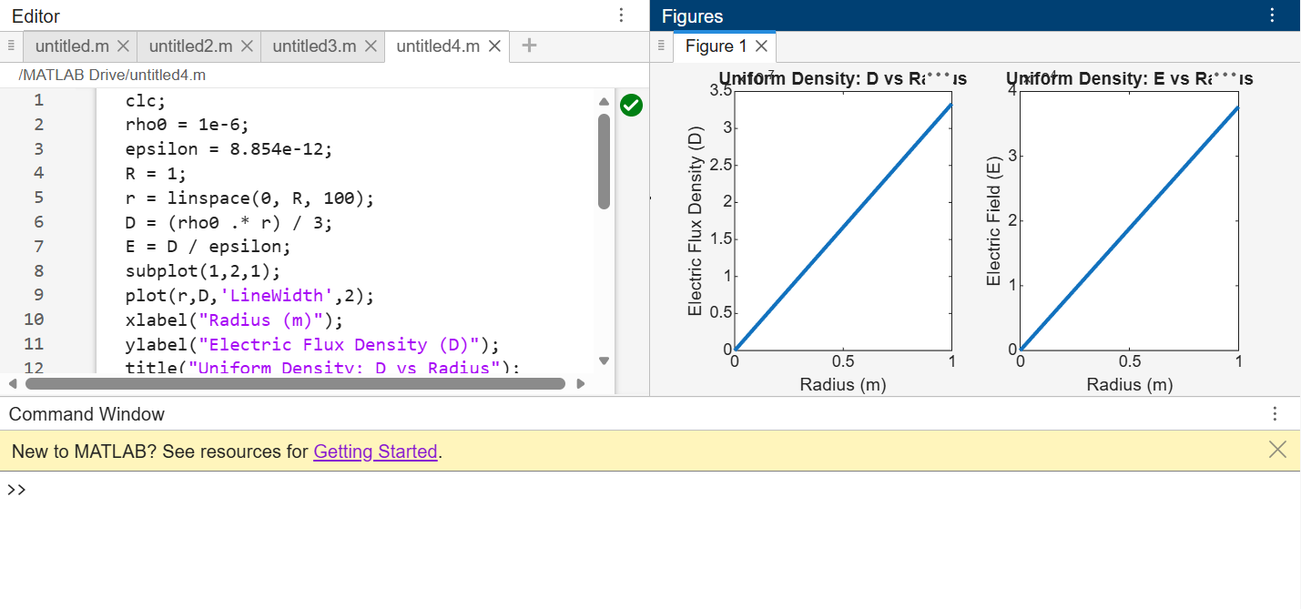

Test case (iii) For a sphere with a linearly increasing charge density ρᵥ = ρ₀r, derive and plot the electric field (E) and electric flux density (D)
Program:
clc;
rho0 = 1e-6;
epsilon = 8.854e-12;
R = 1;
r = linspace(0, R, 100);
D = (rho0 .* r.^2) / 4;
E = D / epsilon;
subplot(1,2,1);
plot(r,D,'LineWidth',2);
xlabel("Radius (m)");
ylabel("Electric Flux Density (D)");
title("Linear Density: D vs Radius");
subplot(1,2,2);
plot(r,E,'LineWidth',2);
xlabel("Radius (m)");
ylabel("Electric Field (E)");
title("Linear Density: E vs Radius");
Output:
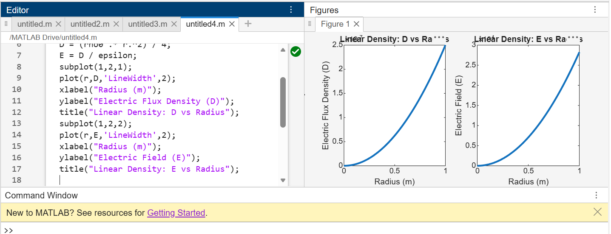
Test case (iv) A sphere of radius R = 2 m has a uniform charge density ρ = 3×10⁻⁶ C/m³. Calculate and plot electric field inside and outside the sphere
Program:
clc;
rho0 = 3e-6;
epsilon = 8.854e-12;
R = 2;
r = linspace(0.1, 4, 100);
E = zeros(size(r));
for i = 1:length(r)
if r(i) < R
E(i) = rho0 * r(i) / (3 * epsilon);
else
Q = rho0 * (4/3) * pi * R^3;
k = 1/(4*pi*epsilon);
E(i) = k * Q / (r(i)^2);
end
end
plot(r,E,'LineWidth',2);
xlabel("Radius (m)");
ylabel("Electric Field (E)");
title("Electric Field Inside and Outside Sphere");
Output:-
• Inside: Linear increase
• Outside: 1/r² decay
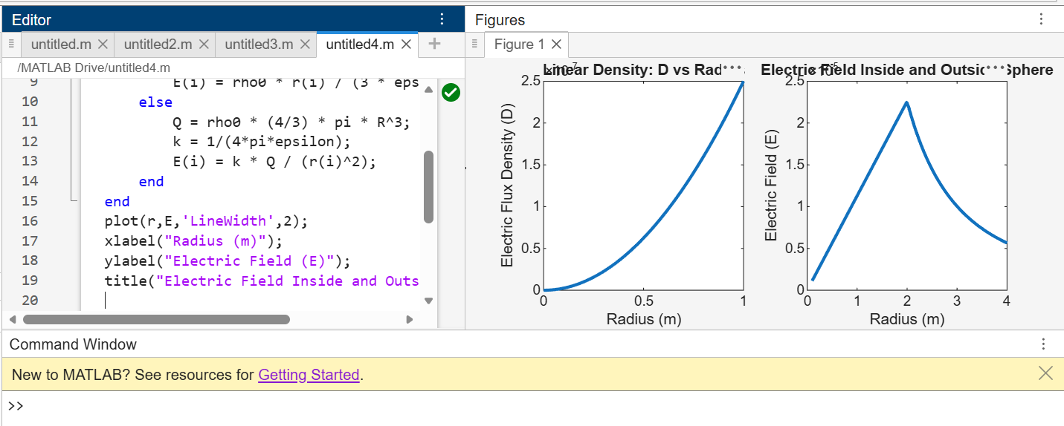

Parameters  q = 2×10⁻² C, r = 1×10⁻⁴ m  ρ₀ = 1×10⁻⁶ C/m³, r = 1 m (inside sphere)  ρᵥ = ρ₀r, r = 1 m  ρ = 3×10⁻⁶ C/m³, R = 2 m (r = 1 m, inside)  ρ = 3×10⁻⁶ C/m³, R = 2 m (r = 3 m, outside) | Observed/Simulated Result | Theoretical Result | Error  Difference  ΔE = 5 × 10¹² ΔD = 1 × 10²  ΔD ≈ 0 ΔE ≈ 0 ΔD ≈ 0 ΔE ≈ 0 ΔE ≈ 0  ΔE ≈ 0
 | E = 1.7975 × 10¹⁶ V/m D = 1.592 × 10⁵ C/m² | E = 1.797 × 10¹⁶ V/m D = 1.591 × 10⁵ C/m²
 | D = 3.33 × 10⁻⁷ C/m² E = 3.76 × 10⁴ V/m | D = 3.33 × 10⁻⁷ C/m² E = 3.76 × 10⁴ V/m
 | D = 2.5 × 10⁻⁷ C/m² E = 2.82 × 10⁴ V/m | D = 2.5 × 10⁻⁷ C/m² E = 2.82 × 10⁴ V/m
 | E = 1.13 × 10⁵ V/m | E = 1.13 × 10⁵ V/m
 | E = 5.65 × 10⁴ V/m | E = 5.65 × 10⁴ V/m

Result :
Thus the program was verified for electric field and electric flux density in sphere using SCILAB was successfully.

